Implementation of User-ID and Password policy on FIS/GGMT system

To print this page, Right click on page & select Print…

Information Systems Directorate is to implement the User-ID and Password policy from the 23rd of April 2007. From this date, you will be required to change your password and thereafter every 30 days. The full version of the policy is available via the following link: GPG_User-ID_and_Password_policy.pdf

HOW TO change your FIS/GGMT Login password?

NOTE:
The procedure applies when you already have access to the system. This does not apply to applications such as BAS, PERSAL,RNMS, SAP, etc.

Figure 1  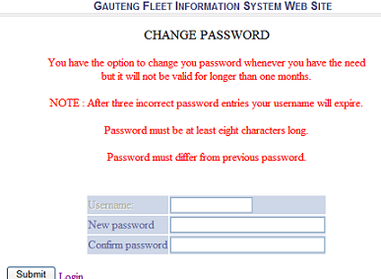 | To change your password, click on Change Password From the Menu opinion. Thereafter, the screen shown in figure1 will appears.

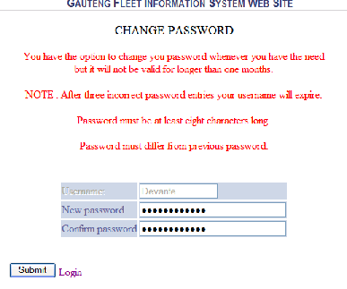  Figure 2  TIP: You should use the Logout button to “logout from the system” whenever the Systems is not in use. | In figure2, Type your New Password and Confirm the password then Click Submit to change your password.  - Be not less than eight characters long in length.  - The previous 3 passwords cannot be repeated.  - Must be mixed with letters or numerals or special symbols or a combination for example, B@th0pe1e meaning Bathopele, M0t1vate meaning Motivate.  Finally, if you follow the procedure correctly, the following message appears.  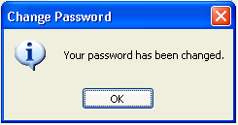

Computer Password Rules
Passwords must not be shared with anyone, including management, co-workers, officials, administrative assistants, or any other party requiring access to an information resource and without authorization. All passwords are to be treated as sensitive, confidential and as private information.

All user-level and system-level passwords need to conform to the following guidelines:
- Do not write passwords on any surface.
- Passwords must not be revealed to anyone over the phone.
- Passwords must not be used or delivered in an electronic mail message.
- Passwords must not be verbally uttered in front of others.
- Hints relating to passwords and the format of passwords are not allowed to be revealed.
- Do not use the "remember password" options allowed for under certain technologies and Internet sites.
- If someone demands a password, refer them to the password policy and ensure that it is not revealed.
Back to top ^

